Name : Teppala Pavan Kumar
Configuring Ubuntu Server (192.168.43.131)
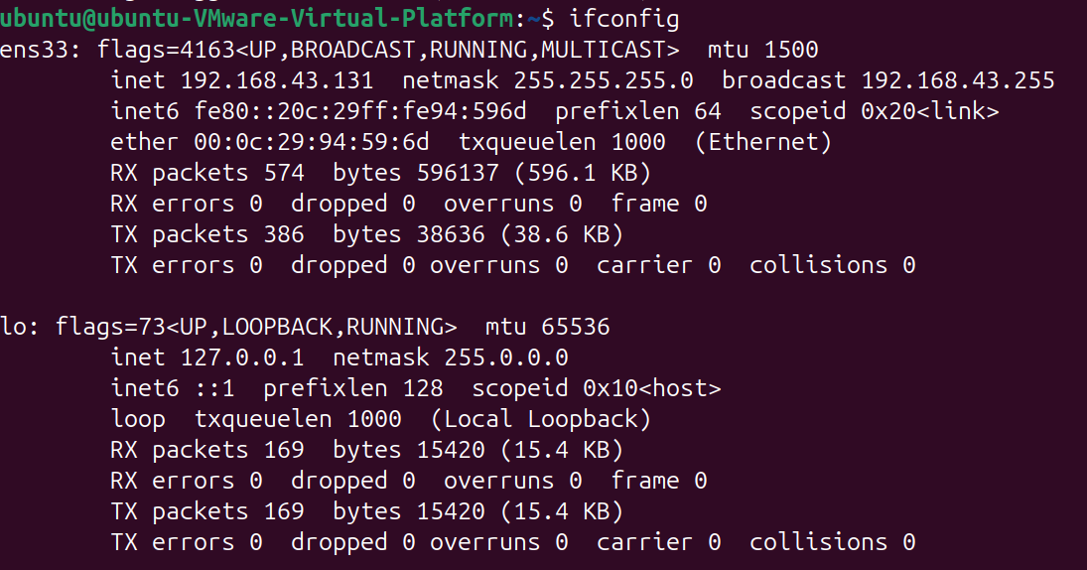

Attacker machine (192.168.43.128)
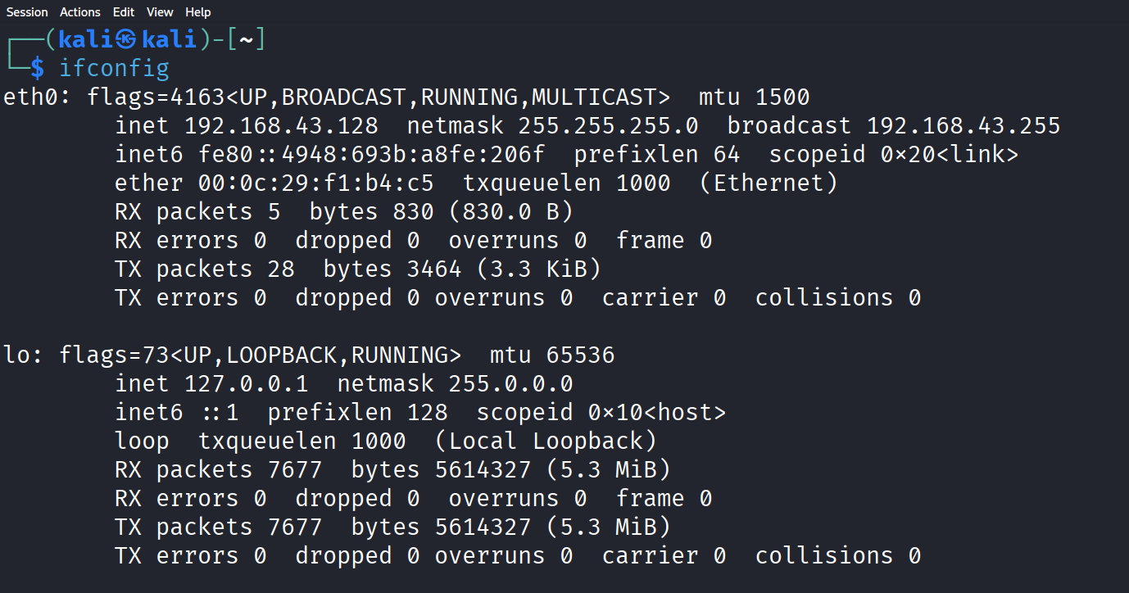

Ping ubuntu machine through attacker machine
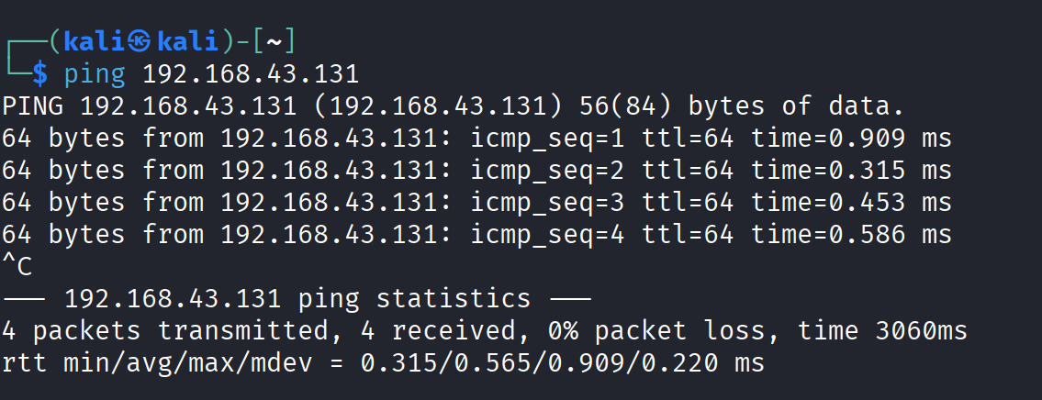

Openssh installation
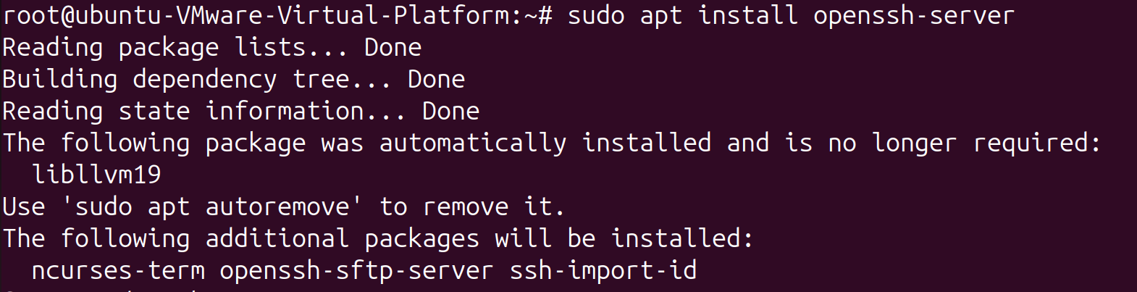

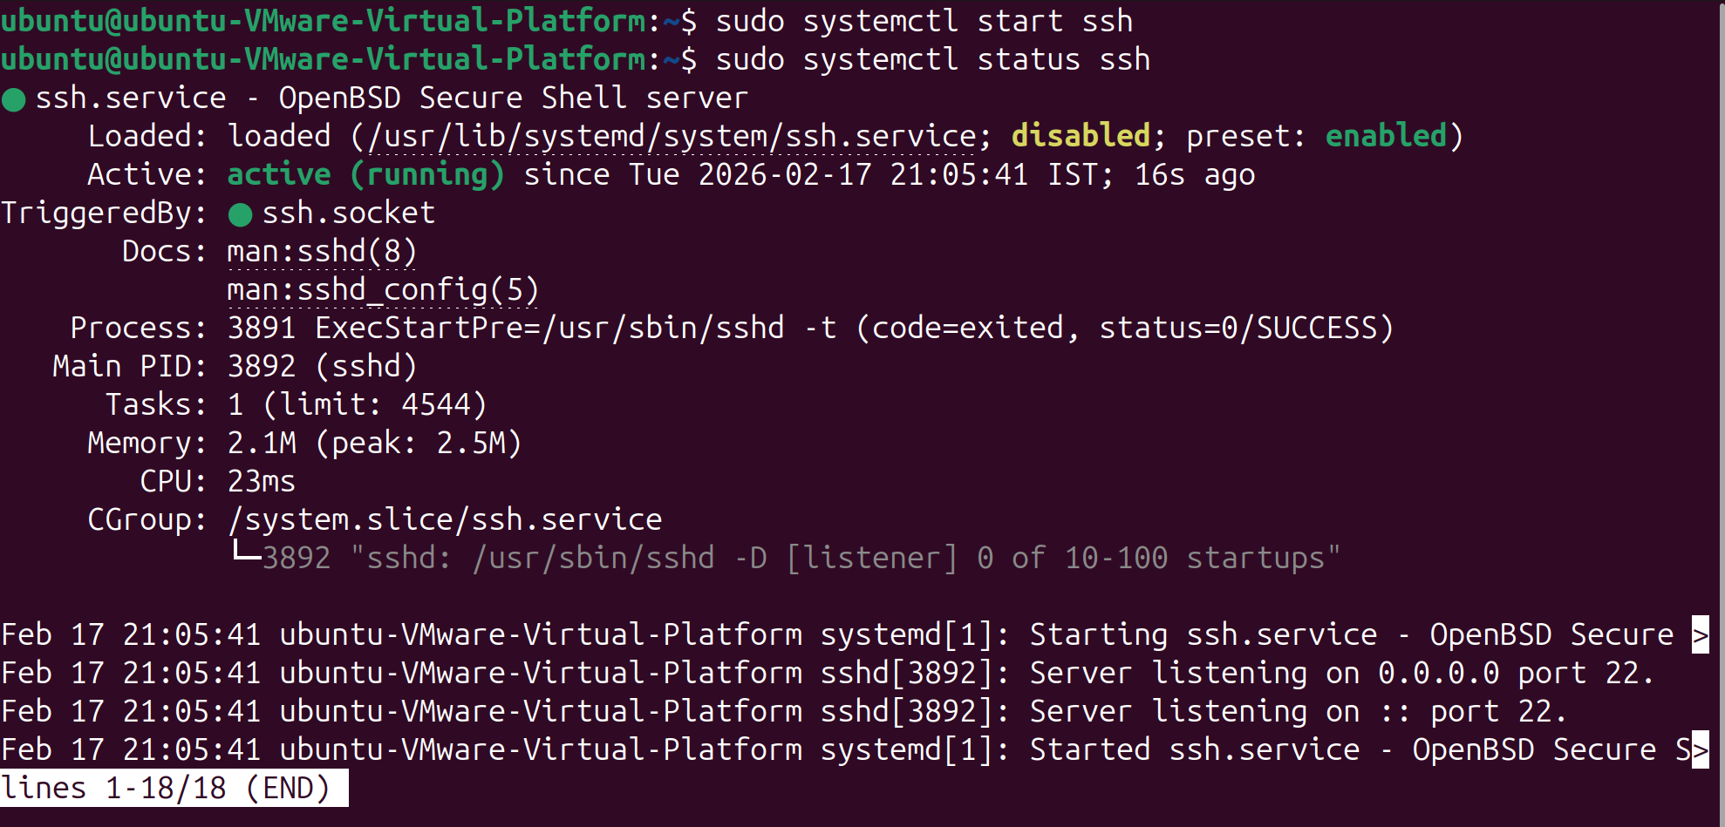

SSH Hardening:
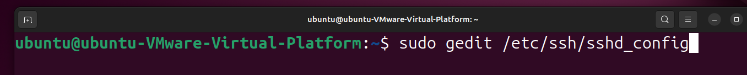

Configuring SSH
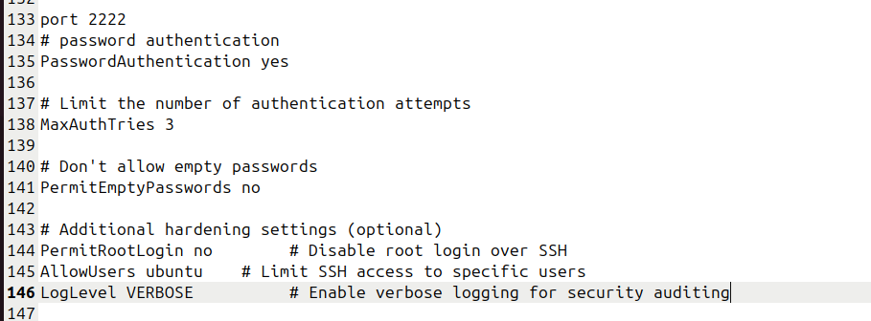

Install vsftpd
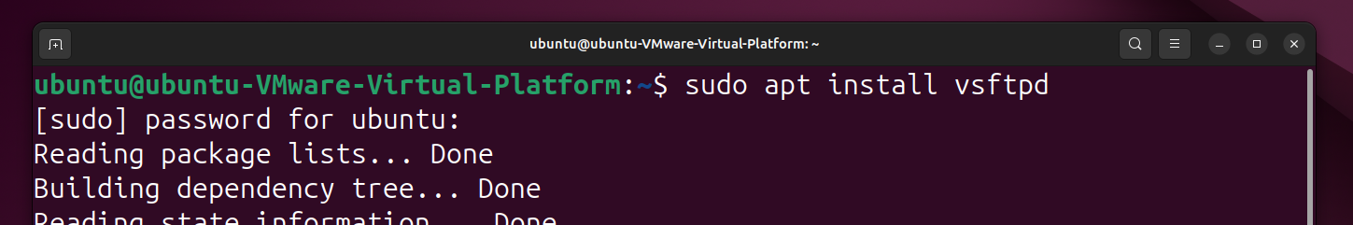

Before making any changes in vsftpd configuration file create a backup file and Configure vsftpd for Honeypot Mode
listen=YES
listen_ipv6=NO

anonymous_enable=NO
local_enable=YES
write_enable=YES

# Jail user (important)
chroot_local_user=YES
allow_writeable_chroot=YES

# Fake writable directory
local_root=/home/ubuntu

# Logging (CRITICAL for honeypot)
xferlog_enable=YES
log_ftp_protocol=YES
vsftpd_log_file=/var/log/vsftpd.log

# Hide real system info
ftpd_banner=Welcome to FTP Service

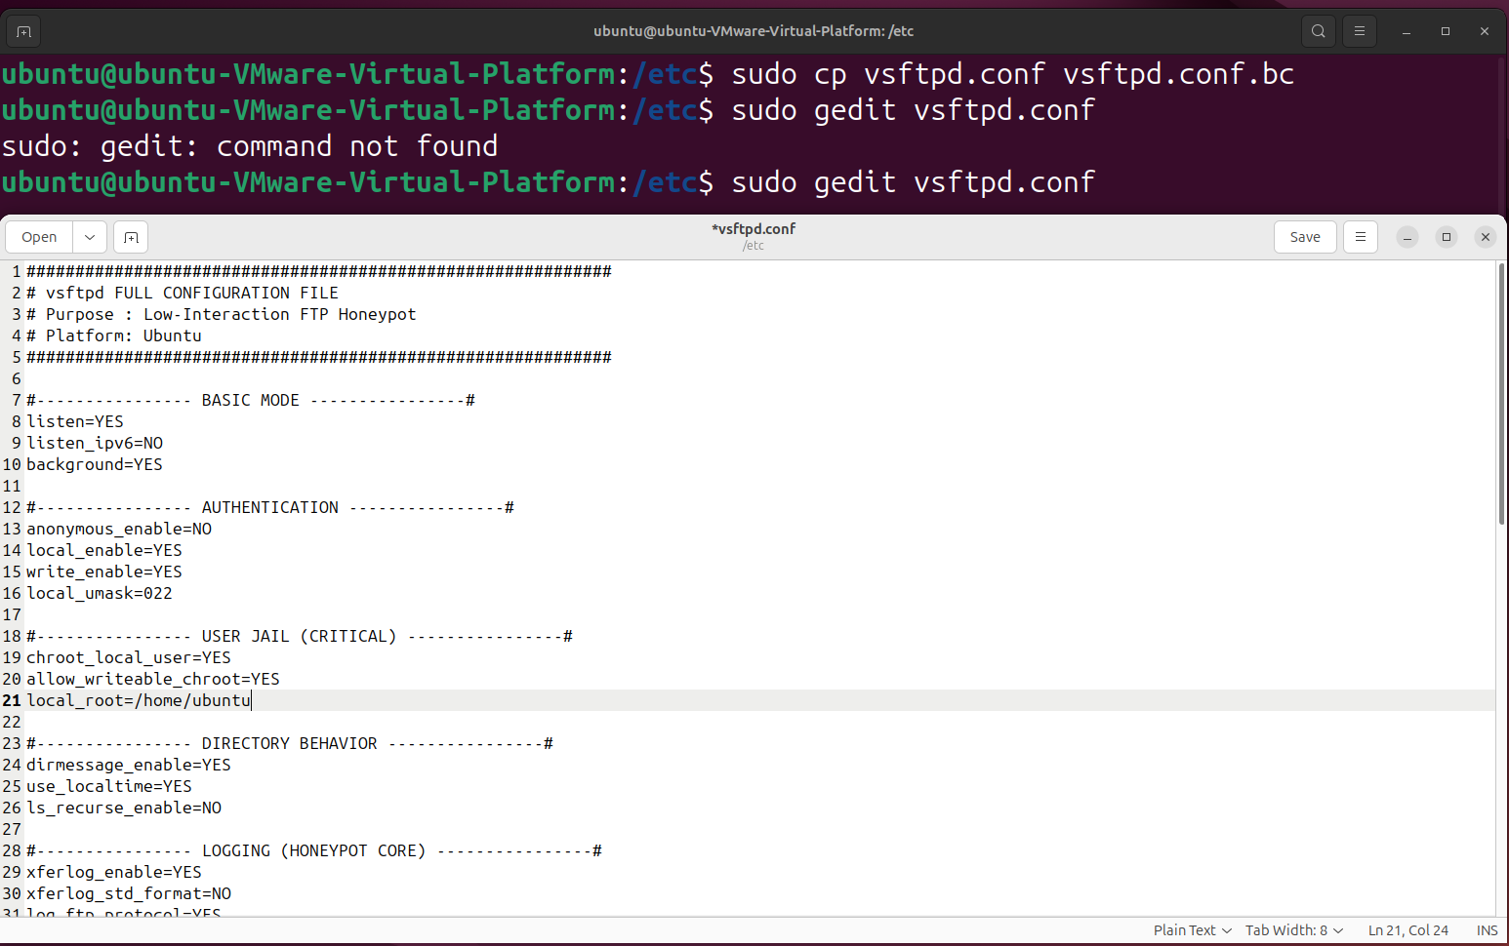

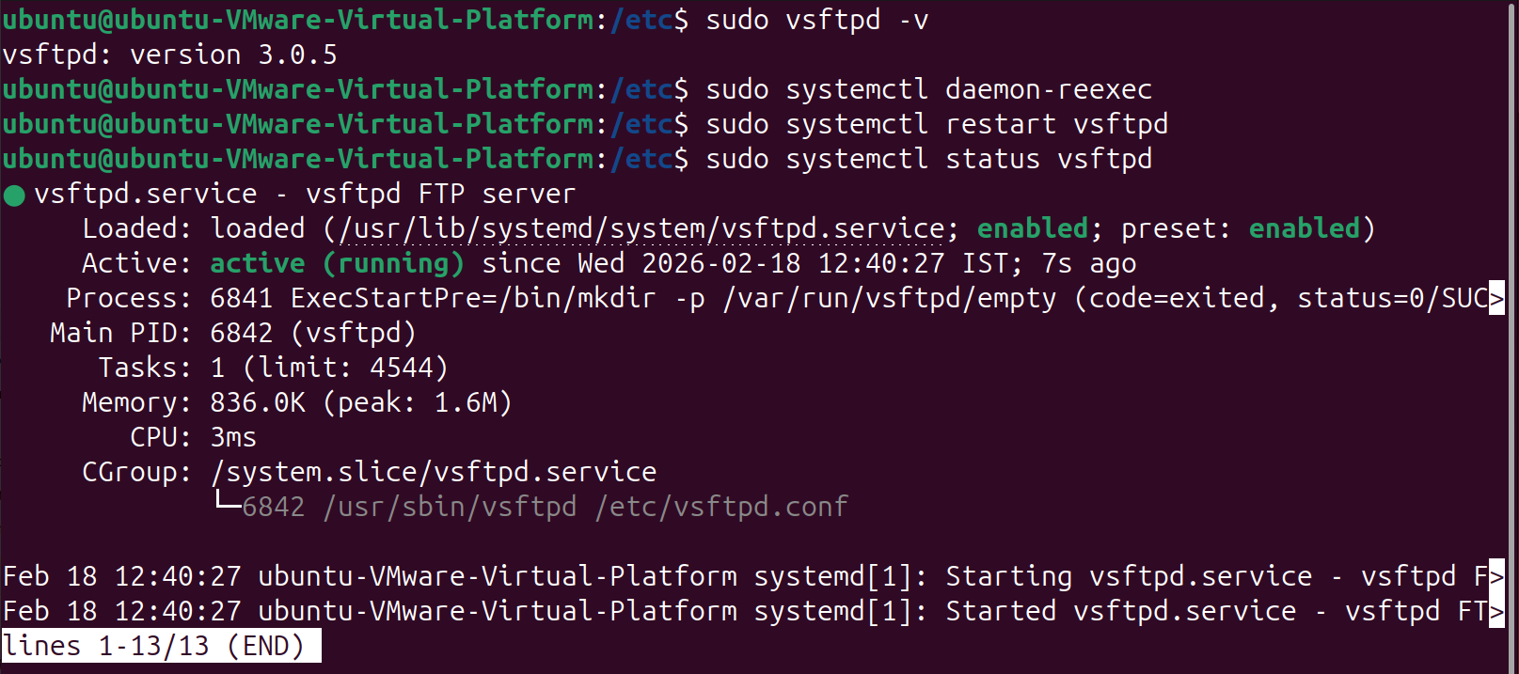

Now creating Fake Honepot Files
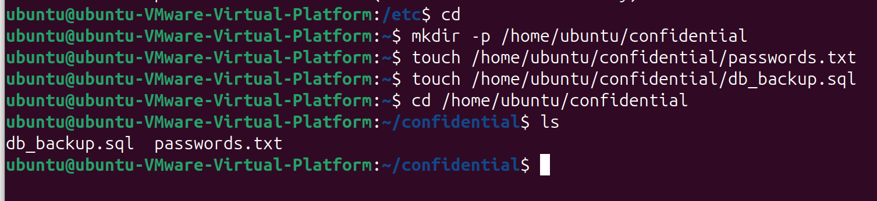

Install and configure firewalld
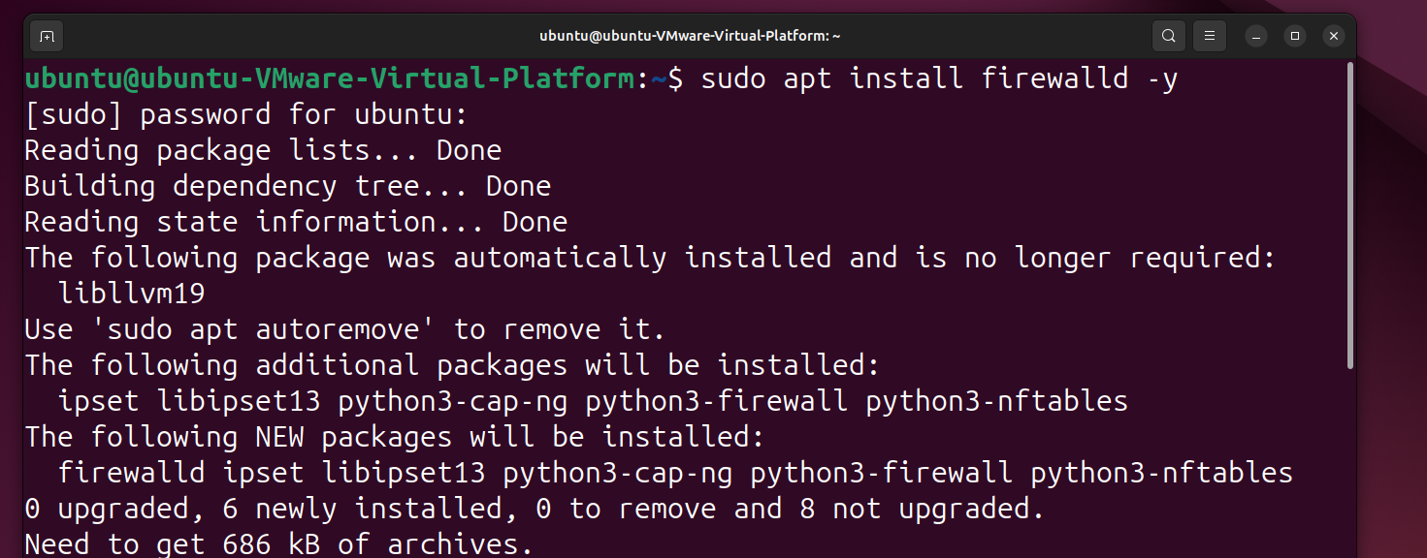

Configuring firewalld (SSH Configuration)
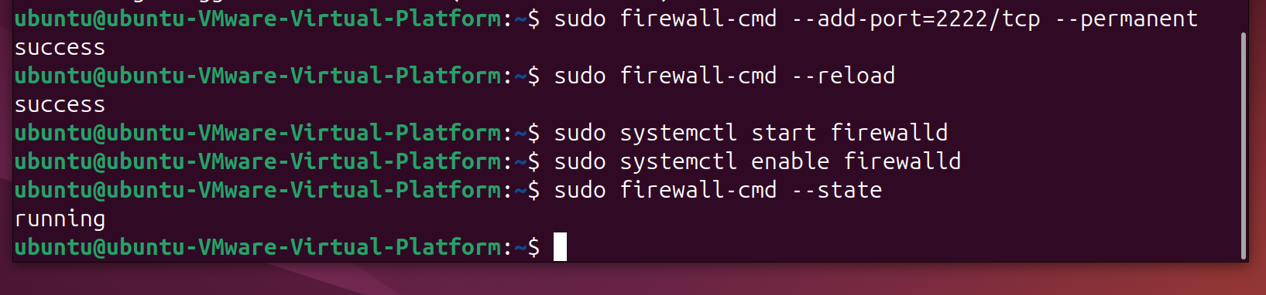

Configuring firewalld (vsftpd Configuration)
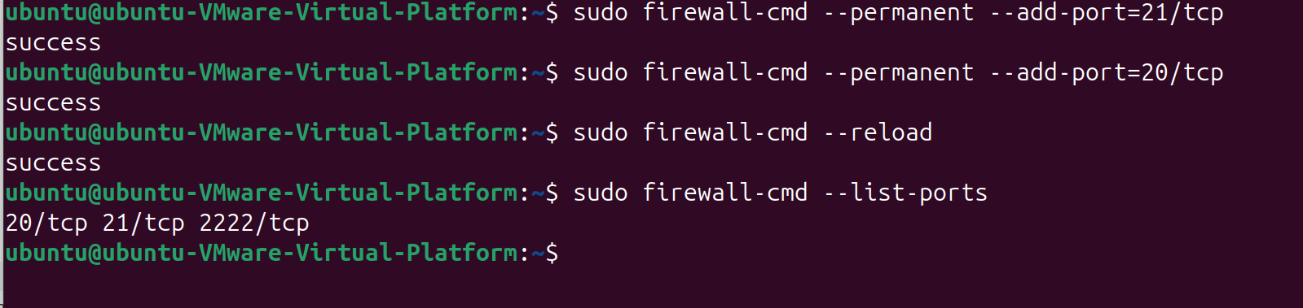

Install and configure fail2ban
Fail2Ban
Fail2Ban is a host-based intrusion prevention system (IPS) used on Linux servers to protect services like SSH, FTP, HTTP, SMTP from brute-force and abuse attempts.
It works by monitoring log files and automatically banning IP addresses that show malicious behavior.
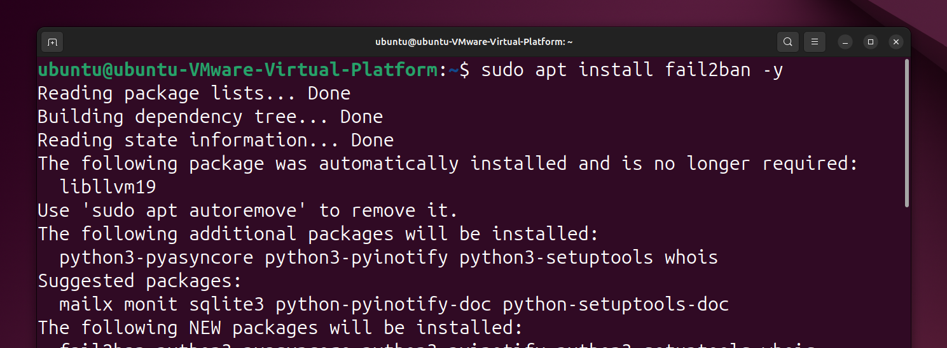

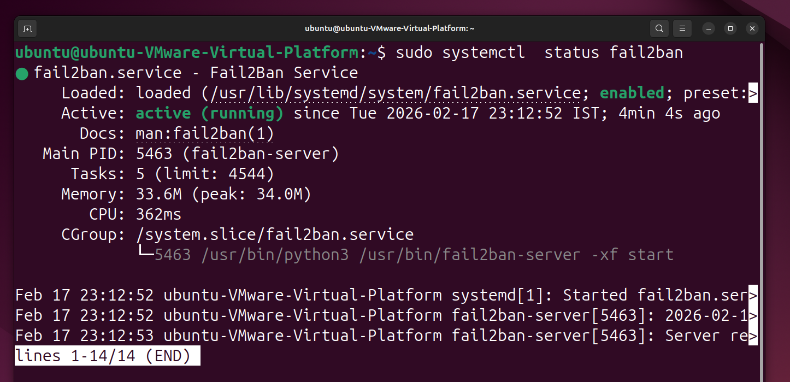

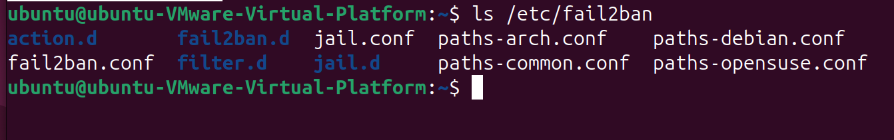

Creating a new jailssh.conf file to protect ssh service:

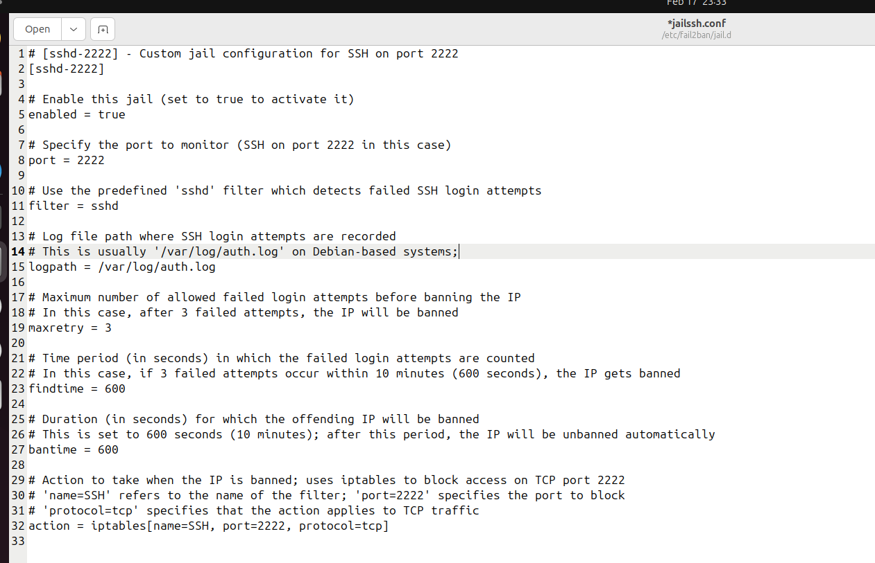

Checking whether the created jailssh.conf file is working or not .
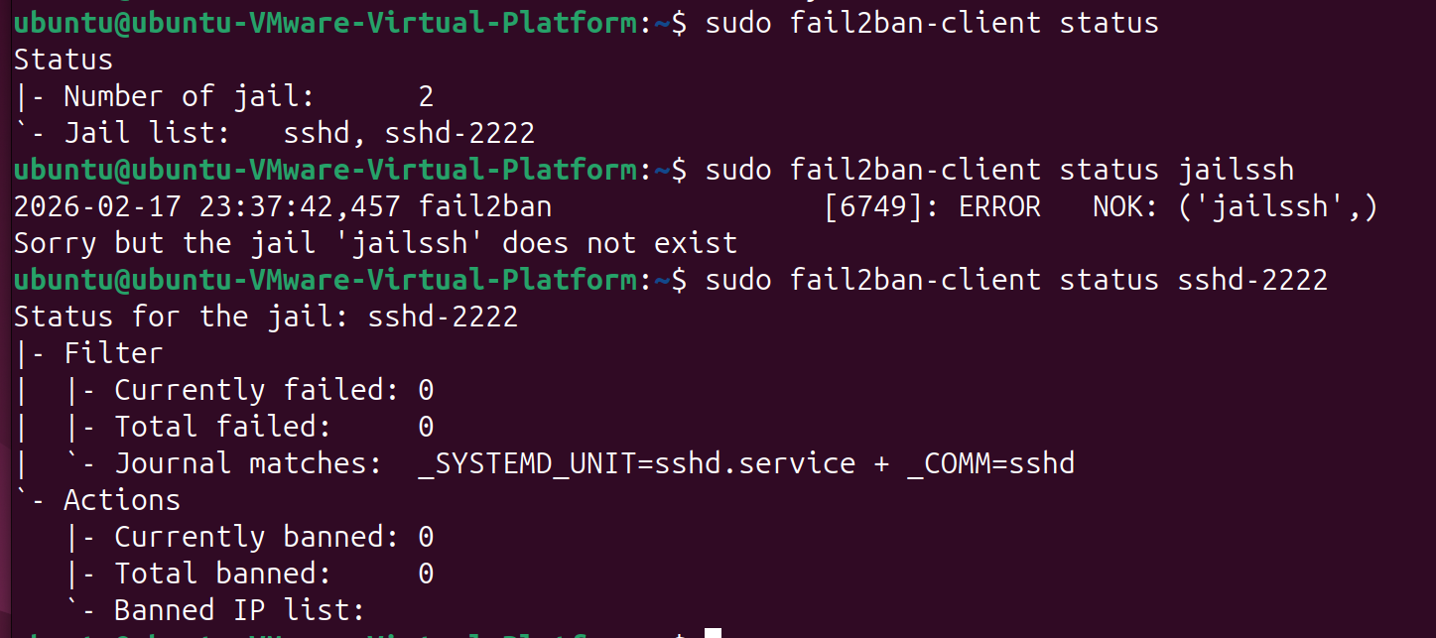

Creating a new vsftpd-honeypot.conf file :
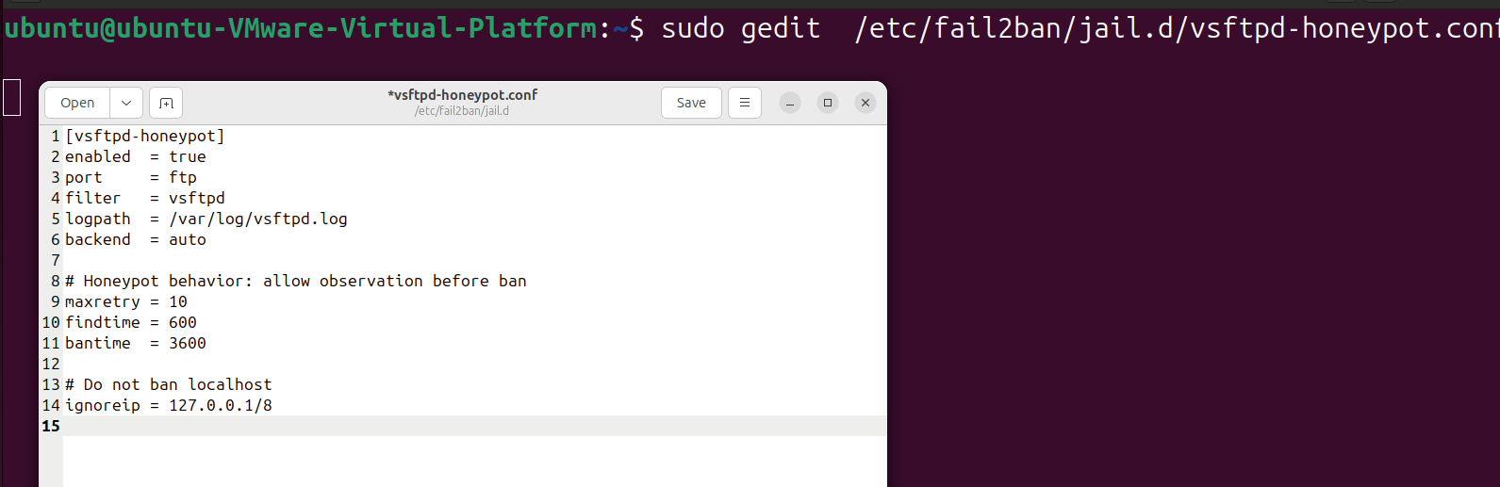

Checking whether the created vsftpd-honeypot.conf file is working or not .
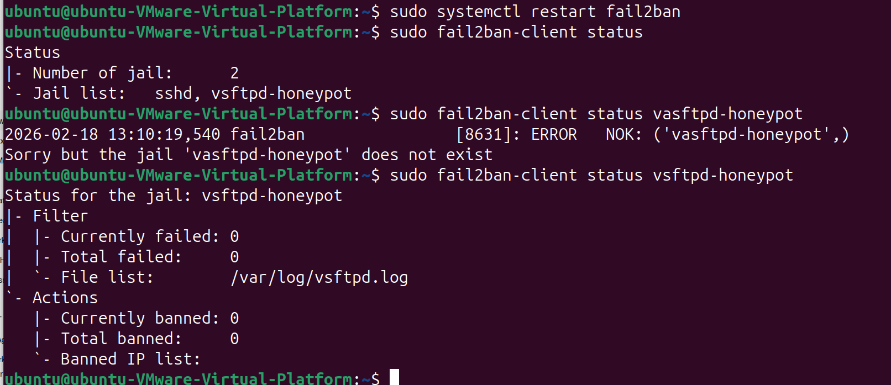
Fail2Ban provides dynamic, firewall-level blocking.
Install SElinux Policycoreutils
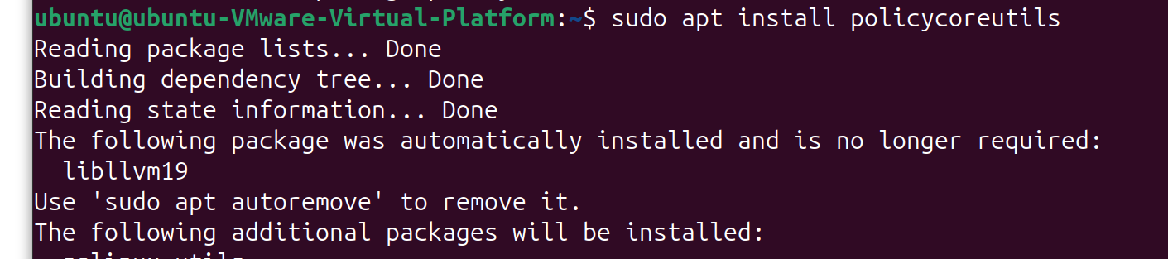

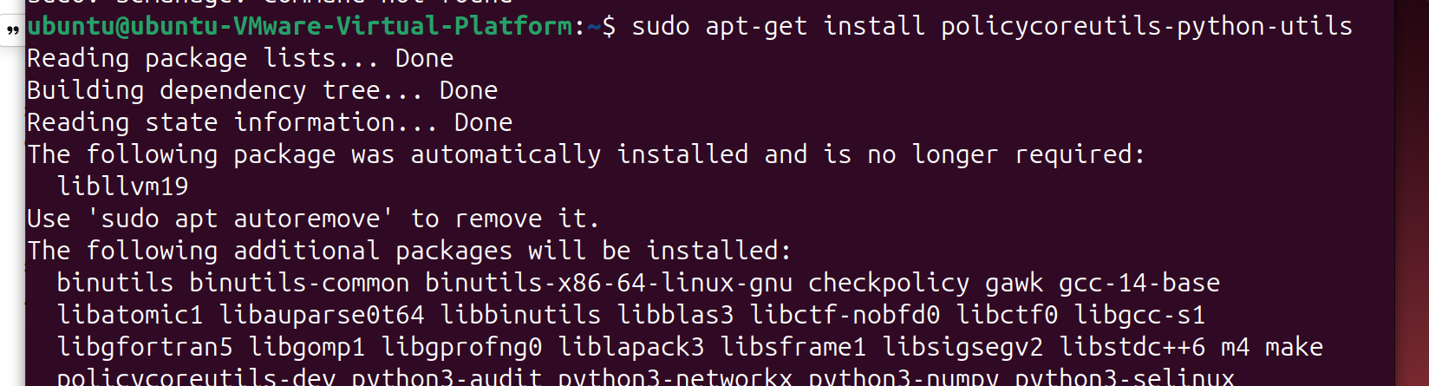

Configuration of SELinux
Changing SELINUXTYPE = default to SELINUXTYPE = enforcing
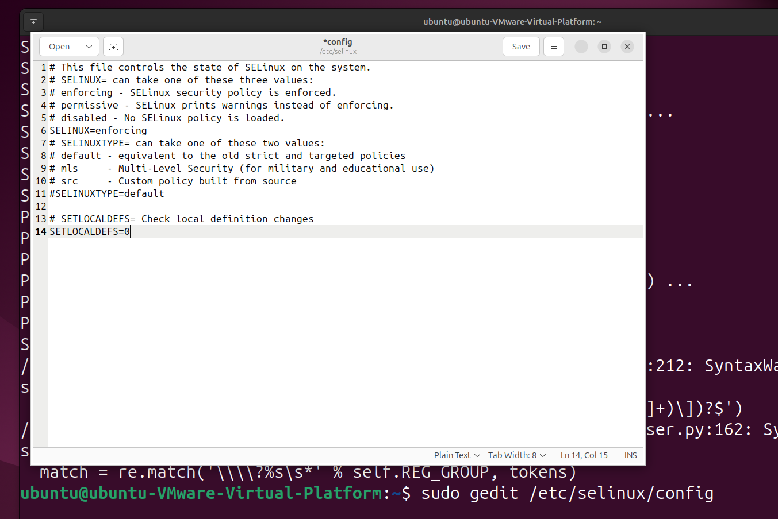
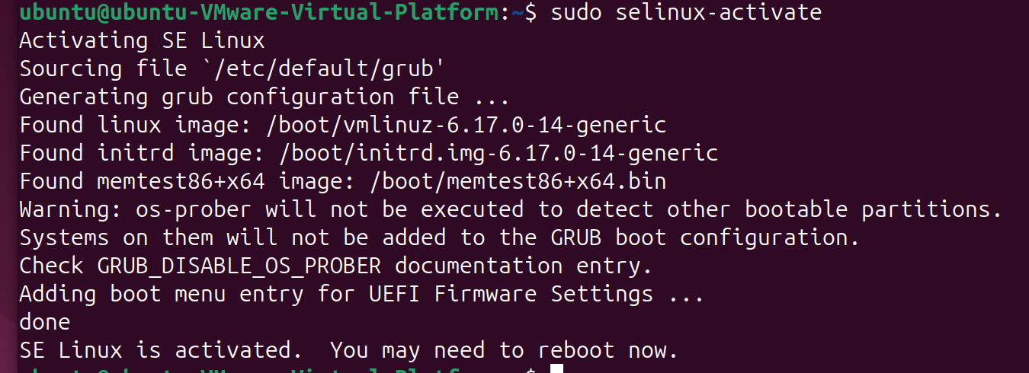

Now writing a monitoring script attack_
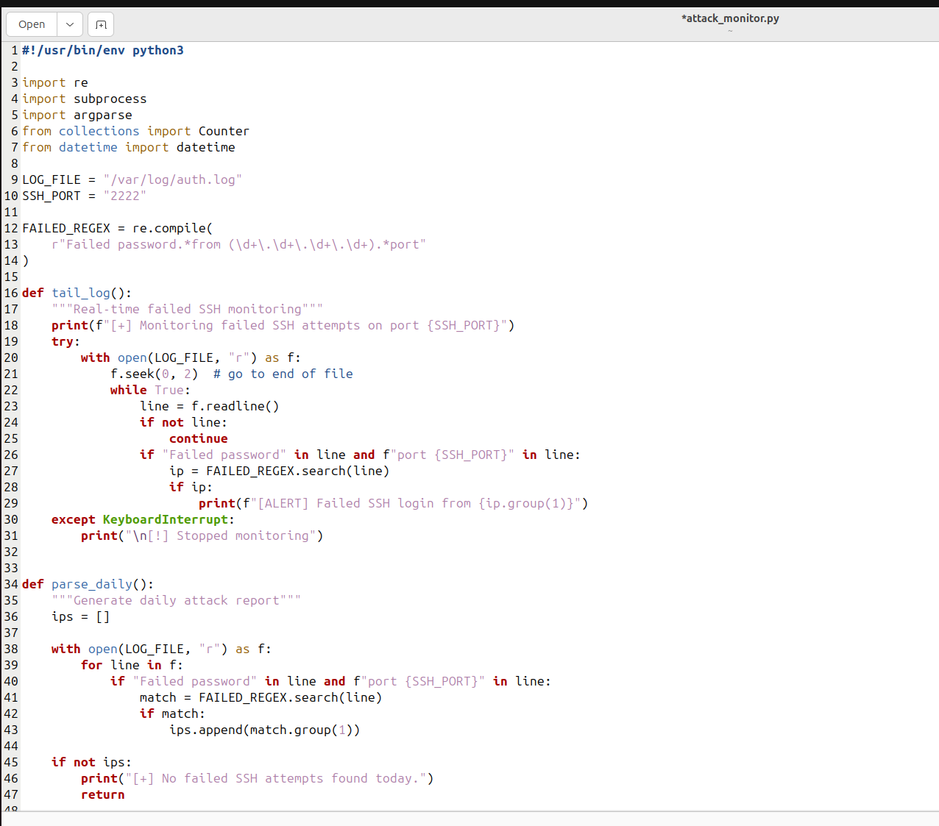

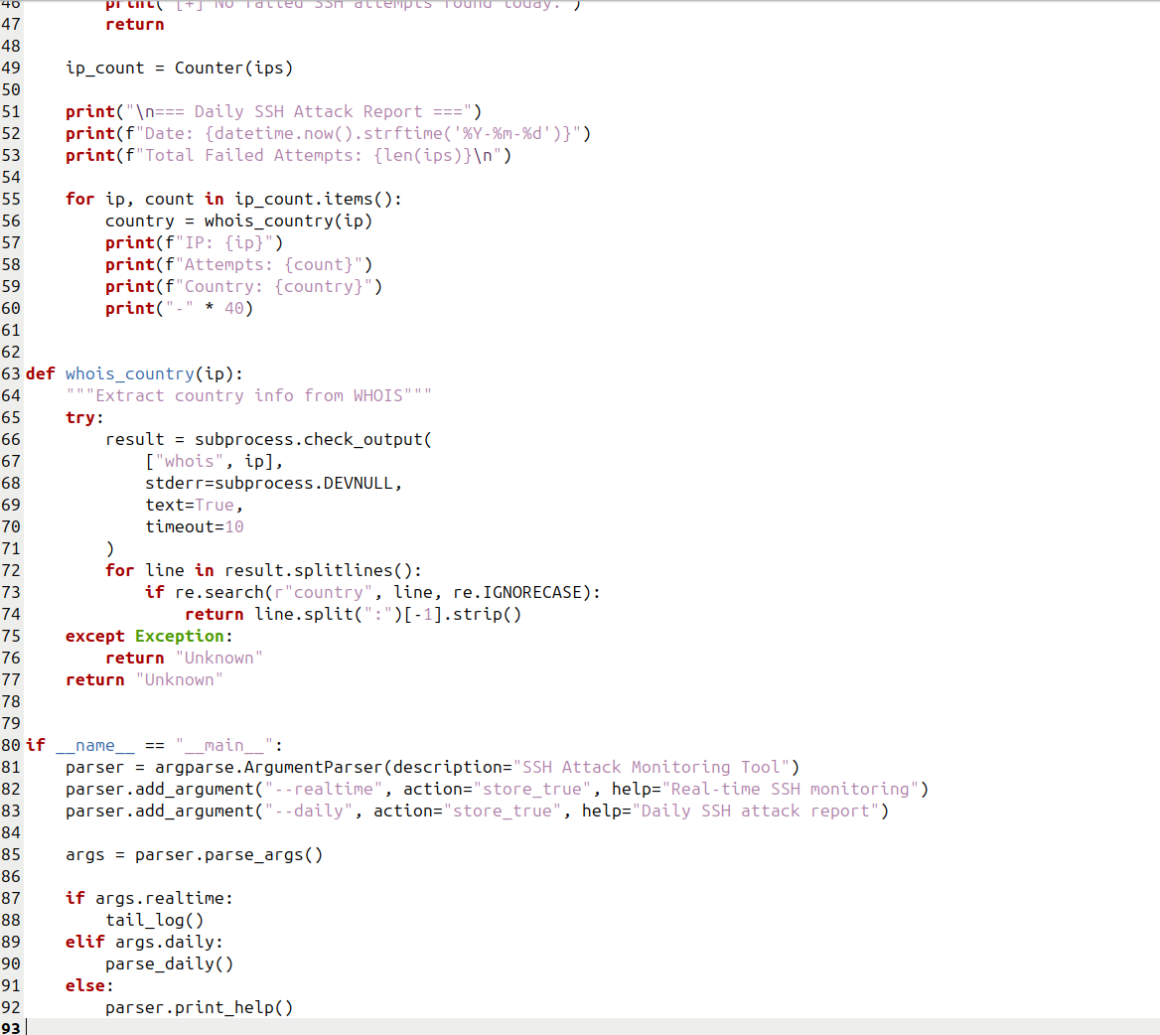

Giving executable permissions to the file
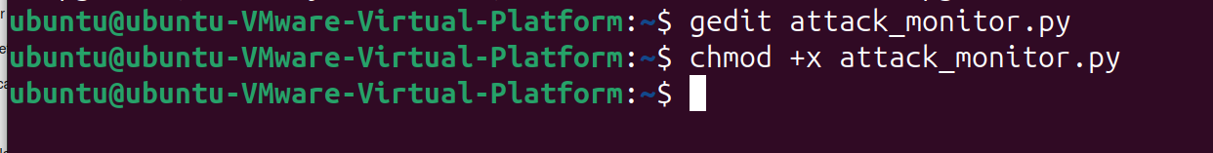

Disable default ssh port and Enabling 2222 port
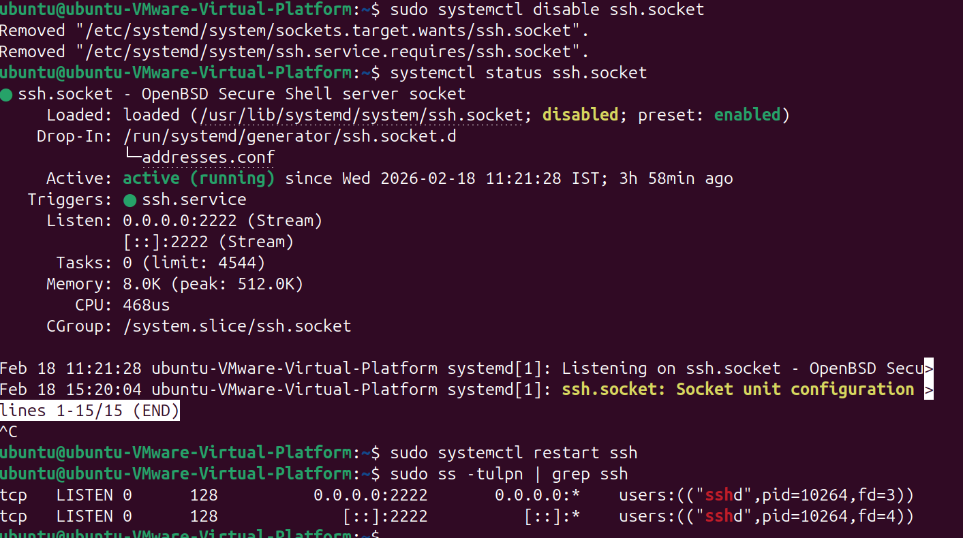

Starting the attack on kali machine
First, we perform reconnaissance on our target machine.
Nmap Scan
-sC Default Scripts Runs a collection of safe, helpful scripts from the Nmap Scripting Engine (NSE) to find common vulnerabilities or extra info.
-sVVersion Detection Probes open ports to determine what software and version is running (e.g., instead of just "Port 80," it tells you "Apache 2.4.41").
-A Aggressive ScanThis is the "All-in-One" flag. It enables OS detection, version detection, script scanning, and traceroute.

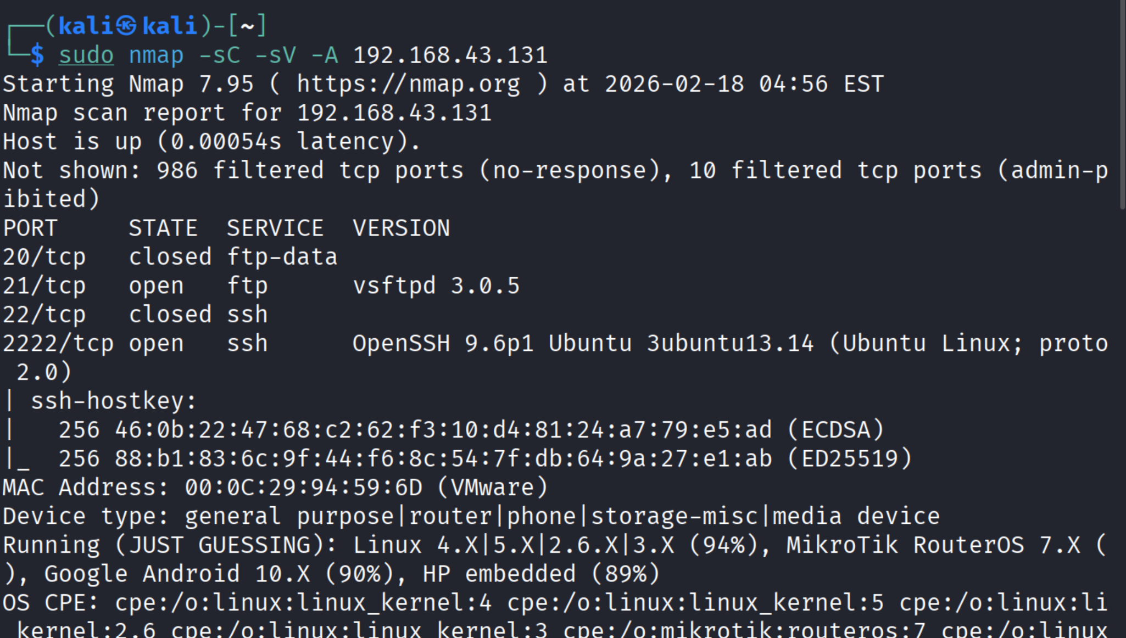

As We can see that ssh (2222) and ftp (21) was open .

Brute-Force SSH Credentials to Gain Access to Servers
Create users.txt
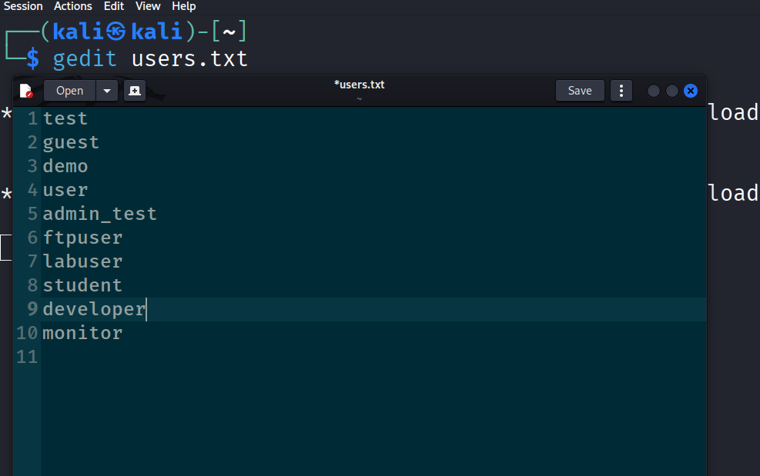

Create passwords.txt
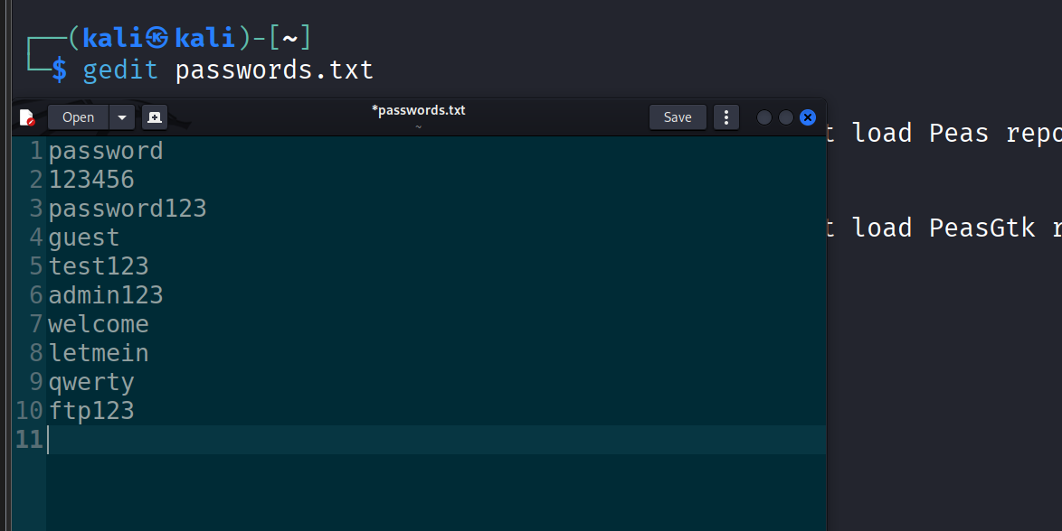
Start attack through nmap script engine
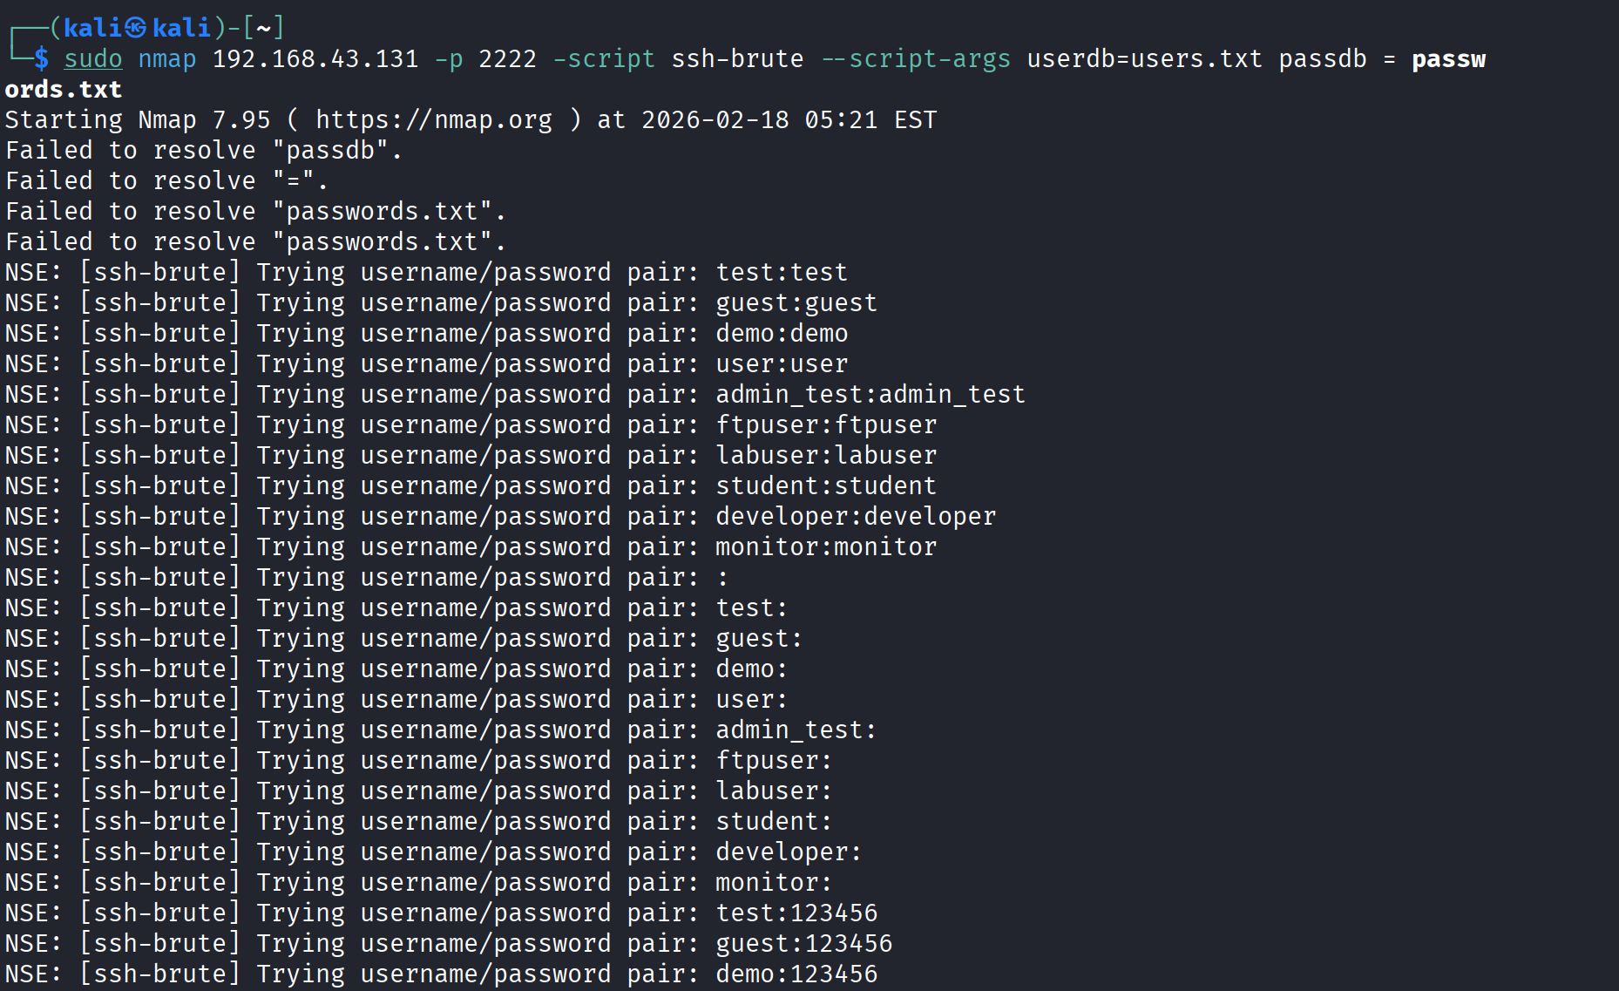

Detecting brute force attacks in ubuntu
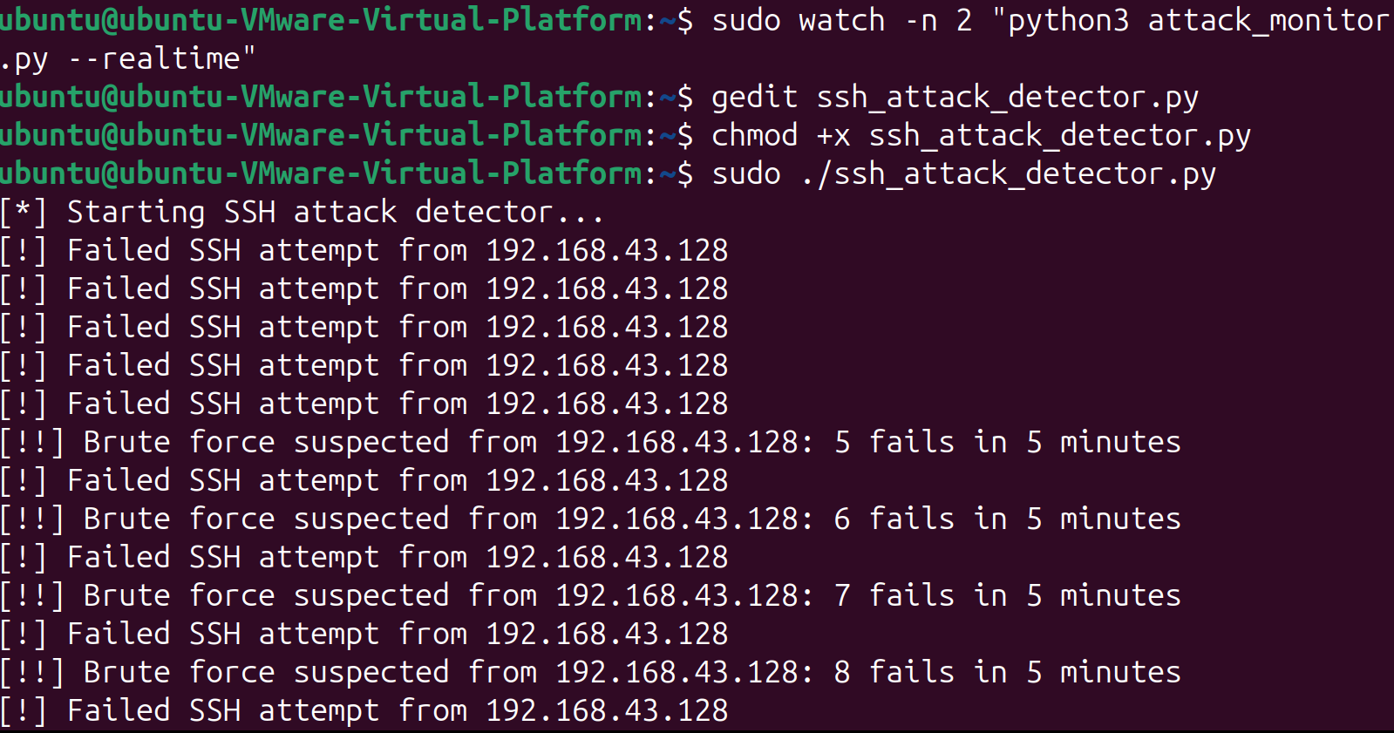
ssh_attack_detector.py
